**Lab 18**

**Name :-** Aryan Dilipbhai Langhanoja

**Date :-** 03-10-2023

**Enrollment No :-** 92200133030

**CO1: To write, test, and debug simple Python programs**

**CO2: To implement Python programs with conditional, loops and functions**

**Task 1:- Write CSV Files Using Pandas**

**Python Code:**

import pandas as pd

data = {

'CHN': {'COUNTRY': 'China', 'POP': 1_398.72, 'AREA': 9_596.96,

'GDP': 12_234.78, 'CONT': 'Asia'},

'IND': {'COUNTRY': 'India', 'POP': 1_351.16, 'AREA': 3_287.26,

'GDP': 2_575.67, 'CONT': 'Asia', 'IND_DAY': '1947-08-15'},

'USA': {'COUNTRY': 'US', 'POP': 329.74, 'AREA': 9_833.52,

'GDP': 19_485.39, 'CONT': 'N.America',

'IND_DAY': '1776-07-04'},

'IDN': {'COUNTRY': 'Indonesia', 'POP': 268.07, 'AREA': 1_910.93,

'GDP': 1_015.54, 'CONT': 'Asia', 'IND_DAY': '1945-08-17'},

'BRA': {'COUNTRY': 'Brazil', 'POP': 210.32, 'AREA': 8_515.77,

'GDP': 2_055.51, 'CONT': 'S.America', 'IND_DAY': '1822-09-07'},

'PAK': {'COUNTRY': 'Pakistan', 'POP': 205.71, 'AREA': 881.91,

'GDP': 302.14, 'CONT': 'Asia', 'IND_DAY': '1947-08-14'},

'NGA': {'COUNTRY': 'Nigeria', 'POP': 200.96, 'AREA': 923.77,

'GDP': 375.77, 'CONT': 'Africa', 'IND_DAY': '1960-10-01'},

'BGD': {'COUNTRY': 'Bangladesh', 'POP': 167.09, 'AREA': 147.57,

'GDP': 245.63, 'CONT': 'Asia', 'IND_DAY': '1971-03-26'},

'RUS': {'COUNTRY': 'Russia', 'POP': 146.79, 'AREA': 17_098.25,

'GDP': 1_530.75, 'IND_DAY': '1992-06-12'},

'MEX': {'COUNTRY': 'Mexico', 'POP': 126.58, 'AREA': 1_964.38,

'GDP': 1_158.23, 'CONT': 'N.America', 'IND_DAY': '1810-09-16'},

'JPN': {'COUNTRY': 'Japan', 'POP': 126.22, 'AREA': 377.97,

'GDP': 4_872.42, 'CONT': 'Asia'},

'DEU': {'COUNTRY': 'Germany', 'POP': 83.02, 'AREA': 357.11,

'GDP': 3_693.20, 'CONT': 'Europe'},

'FRA': {'COUNTRY': 'France', 'POP': 67.02, 'AREA': 640.68,

'GDP': 2_582.49, 'CONT': 'Europe', 'IND_DAY': '1789-07-14'},

'GBR': {'COUNTRY': 'UK', 'POP': 66.44, 'AREA': 242.50,

'GDP': 2_631.23, 'CONT': 'Europe'},

'ITA': {'COUNTRY': 'Italy', 'POP': 60.36, 'AREA': 301.34,

'GDP': 1_943.84, 'CONT': 'Europe'},

'ARG': {'COUNTRY': 'Argentina', 'POP': 44.94, 'AREA': 2_780.40,

'GDP': 637.49, 'CONT': 'S.America', 'IND_DAY': '1816-07-09'},

'DZA': {'COUNTRY': 'Algeria', 'POP': 43.38, 'AREA': 2_381.74,

'GDP': 167.56, 'CONT': 'Africa', 'IND_DAY': '1962-07-05'},

'CAN': {'COUNTRY': 'Canada', 'POP': 37.59, 'AREA': 9_984.67,

'GDP': 1_647.12, 'CONT': 'N.America', 'IND_DAY': '1867-07-01'},

'AUS': {'COUNTRY': 'Australia', 'POP': 25.47, 'AREA': 7_692.02,

'GDP': 1_408.68, 'CONT': 'Oceania'},

'KAZ': {'COUNTRY': 'Kazakhstan', 'POP': 18.53, 'AREA': 2_724.90,

'GDP': 159.41, 'CONT': 'Asia', 'IND_DAY': '1991-12-16'}

}

columns = ('COUNTRY', 'POP', 'AREA', 'GDP', 'CONT', 'IND_DAY')

df = pd.DataFrame(data=data).T

df.to_csv('data.csv')

df2 = pd.DataFrame(data=data, index=columns).T

print(df2)

**Output:**

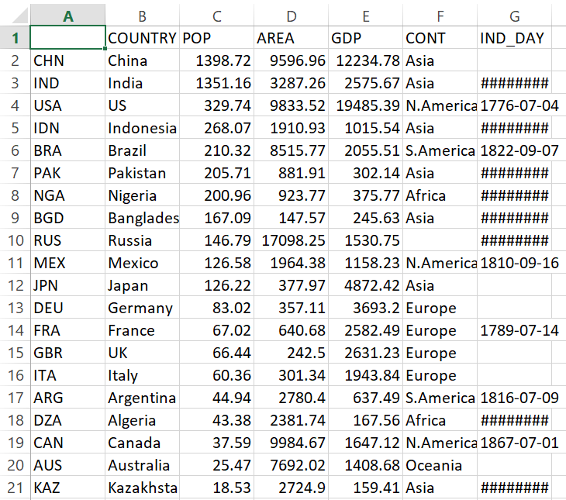

**Task 2:- Read CSV Files Using Pandas**

**Python Code:**

import pandas as pd

df3 = pd.read_csv('data.csv', index_col=0)

print(df3)

**Output:**

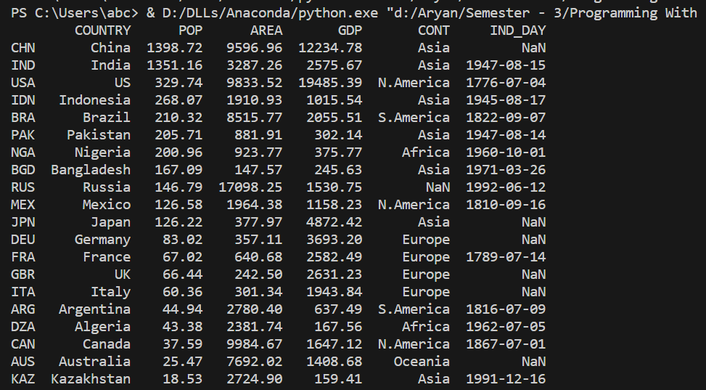

**Task 3:-** **Write Excel Files Using Pandas**

**Python Code:**

import pandas as pd

data = {

'CHN': {'COUNTRY': 'China', 'POP': 1_398.72, 'AREA': 9_596.96,

'GDP': 12_234.78, 'CONT': 'Asia'},

'IND': {'COUNTRY': 'India', 'POP': 1_351.16, 'AREA': 3_287.26,

'GDP': 2_575.67, 'CONT': 'Asia', 'IND_DAY': '1947-08-15'},

'USA': {'COUNTRY': 'US', 'POP': 329.74, 'AREA': 9_833.52,

'GDP': 19_485.39, 'CONT': 'N.America',

'IND_DAY': '1776-07-04'},

'IDN': {'COUNTRY': 'Indonesia', 'POP': 268.07, 'AREA': 1_910.93,

'GDP': 1_015.54, 'CONT': 'Asia', 'IND_DAY': '1945-08-17'},

'BRA': {'COUNTRY': 'Brazil', 'POP': 210.32, 'AREA': 8_515.77,

'GDP': 2_055.51, 'CONT': 'S.America', 'IND_DAY': '1822-09-07'},

'PAK': {'COUNTRY': 'Pakistan', 'POP': 205.71, 'AREA': 881.91,

'GDP': 302.14, 'CONT': 'Asia', 'IND_DAY': '1947-08-14'},

'NGA': {'COUNTRY': 'Nigeria', 'POP': 200.96, 'AREA': 923.77,

'GDP': 375.77, 'CONT': 'Africa', 'IND_DAY': '1960-10-01'},

'BGD': {'COUNTRY': 'Bangladesh', 'POP': 167.09, 'AREA': 147.57,

'GDP': 245.63, 'CONT': 'Asia', 'IND_DAY': '1971-03-26'},

'RUS': {'COUNTRY': 'Russia', 'POP': 146.79, 'AREA': 17_098.25,

'GDP': 1_530.75, 'IND_DAY': '1992-06-12'},

'MEX': {'COUNTRY': 'Mexico', 'POP': 126.58, 'AREA': 1_964.38,

'GDP': 1_158.23, 'CONT': 'N.America', 'IND_DAY': '1810-09-16'},

'JPN': {'COUNTRY': 'Japan', 'POP': 126.22, 'AREA': 377.97,

'GDP': 4_872.42, 'CONT': 'Asia'},

'DEU': {'COUNTRY': 'Germany', 'POP': 83.02, 'AREA': 357.11,

'GDP': 3_693.20, 'CONT': 'Europe'},

'FRA': {'COUNTRY': 'France', 'POP': 67.02, 'AREA': 640.68,

'GDP': 2_582.49, 'CONT': 'Europe', 'IND_DAY': '1789-07-14'},

'GBR': {'COUNTRY': 'UK', 'POP': 66.44, 'AREA': 242.50,

'GDP': 2_631.23, 'CONT': 'Europe'},

'ITA': {'COUNTRY': 'Italy', 'POP': 60.36, 'AREA': 301.34,

'GDP': 1_943.84, 'CONT': 'Europe'},

'ARG': {'COUNTRY': 'Argentina', 'POP': 44.94, 'AREA': 2_780.40,

'GDP': 637.49, 'CONT': 'S.America', 'IND_DAY': '1816-07-09'},

'DZA': {'COUNTRY': 'Algeria', 'POP': 43.38, 'AREA': 2_381.74,

'GDP': 167.56, 'CONT': 'Africa', 'IND_DAY': '1962-07-05'},

'CAN': {'COUNTRY': 'Canada', 'POP': 37.59, 'AREA': 9_984.67,

'GDP': 1_647.12, 'CONT': 'N.America', 'IND_DAY': '1867-07-01'},

'AUS': {'COUNTRY': 'Australia', 'POP': 25.47, 'AREA': 7_692.02,

'GDP': 1_408.68, 'CONT': 'Oceania'},

'KAZ': {'COUNTRY': 'Kazakhstan', 'POP': 18.53, 'AREA': 2_724.90,

'GDP': 159.41, 'CONT': 'Asia', 'IND_DAY': '1991-12-16'}

}

columns = ('COUNTRY', 'POP', 'AREA', 'GDP', 'CONT', 'IND_DAY')

df4 = pd.DataFrame(data=data, index=columns).T

df4.to_excel('data.xlsx')

**Output:**

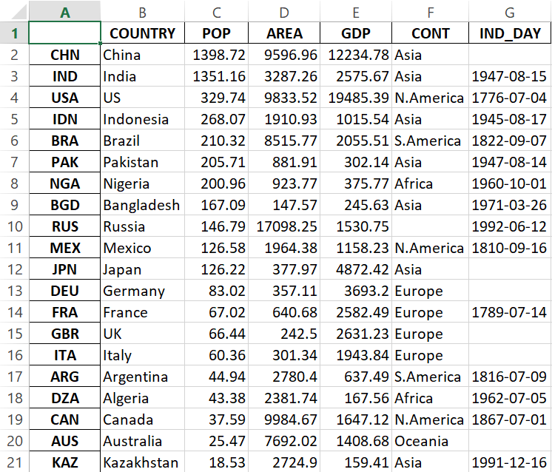

**Task 4:- Checking The DataTypes of Each Column In Dataframe**

**Python Code:**

import pandas as pd

df5 = pd.read_excel('data.xlsx', index_col=0)

print(pd)

**Output:**



**Task 5:- Write json File**

**Python Code:**

import pandas as pd

data = {

'CHN': {'COUNTRY': 'China', 'POP': 1_398.72, 'AREA': 9_596.96,

'GDP': 12_234.78, 'CONT': 'Asia'},

'IND': {'COUNTRY': 'India', 'POP': 1_351.16, 'AREA': 3_287.26,

'GDP': 2_575.67, 'CONT': 'Asia', 'IND_DAY': '1947-08-15'},

'USA': {'COUNTRY': 'US', 'POP': 329.74, 'AREA': 9_833.52,

'GDP': 19_485.39, 'CONT': 'N.America',

'IND_DAY': '1776-07-04'},

'IDN': {'COUNTRY': 'Indonesia', 'POP': 268.07, 'AREA': 1_910.93,

'GDP': 1_015.54, 'CONT': 'Asia', 'IND_DAY': '1945-08-17'},

'BRA': {'COUNTRY': 'Brazil', 'POP': 210.32, 'AREA': 8_515.77,

'GDP': 2_055.51, 'CONT': 'S.America', 'IND_DAY': '1822-09-07'},

'PAK': {'COUNTRY': 'Pakistan', 'POP': 205.71, 'AREA': 881.91,

'GDP': 302.14, 'CONT': 'Asia', 'IND_DAY': '1947-08-14'},

'NGA': {'COUNTRY': 'Nigeria', 'POP': 200.96, 'AREA': 923.77,

'GDP': 375.77, 'CONT': 'Africa', 'IND_DAY': '1960-10-01'},

'BGD': {'COUNTRY': 'Bangladesh', 'POP': 167.09, 'AREA': 147.57,

'GDP': 245.63, 'CONT': 'Asia', 'IND_DAY': '1971-03-26'},

'RUS': {'COUNTRY': 'Russia', 'POP': 146.79, 'AREA': 17_098.25,

'GDP': 1_530.75, 'IND_DAY': '1992-06-12'},

'MEX': {'COUNTRY': 'Mexico', 'POP': 126.58, 'AREA': 1_964.38,

'GDP': 1_158.23, 'CONT': 'N.America', 'IND_DAY': '1810-09-16'},

'JPN': {'COUNTRY': 'Japan', 'POP': 126.22, 'AREA': 377.97,

'GDP': 4_872.42, 'CONT': 'Asia'},

'DEU': {'COUNTRY': 'Germany', 'POP': 83.02, 'AREA': 357.11,

'GDP': 3_693.20, 'CONT': 'Europe'},

'FRA': {'COUNTRY': 'France', 'POP': 67.02, 'AREA': 640.68,

'GDP': 2_582.49, 'CONT': 'Europe', 'IND_DAY': '1789-07-14'},

'GBR': {'COUNTRY': 'UK', 'POP': 66.44, 'AREA': 242.50,

'GDP': 2_631.23, 'CONT': 'Europe'},

'ITA': {'COUNTRY': 'Italy', 'POP': 60.36, 'AREA': 301.34,

'GDP': 1_943.84, 'CONT': 'Europe'},

'ARG': {'COUNTRY': 'Argentina', 'POP': 44.94, 'AREA': 2_780.40,

'GDP': 637.49, 'CONT': 'S.America', 'IND_DAY': '1816-07-09'},

'DZA': {'COUNTRY': 'Algeria', 'POP': 43.38, 'AREA': 2_381.74,

'GDP': 167.56, 'CONT': 'Africa', 'IND_DAY': '1962-07-05'},

'CAN': {'COUNTRY': 'Canada', 'POP': 37.59, 'AREA': 9_984.67,

'GDP': 1_647.12, 'CONT': 'N.America', 'IND_DAY': '1867-07-01'},

'AUS': {'COUNTRY': 'Australia', 'POP': 25.47, 'AREA': 7_692.02,

'GDP': 1_408.68, 'CONT': 'Oceania'},

'KAZ': {'COUNTRY': 'Kazakhstan', 'POP': 18.53, 'AREA': 2_724.90,

'GDP': 159.41, 'CONT': 'Asia', 'IND_DAY': '1991-12-16'}

}

columns = ('COUNTRY', 'POP', 'AREA', 'GDP', 'CONT', 'IND_DAY')

df6 = pd.DataFrame(data=data, index=columns).T

df6.to_json('data.json')

**Output:**

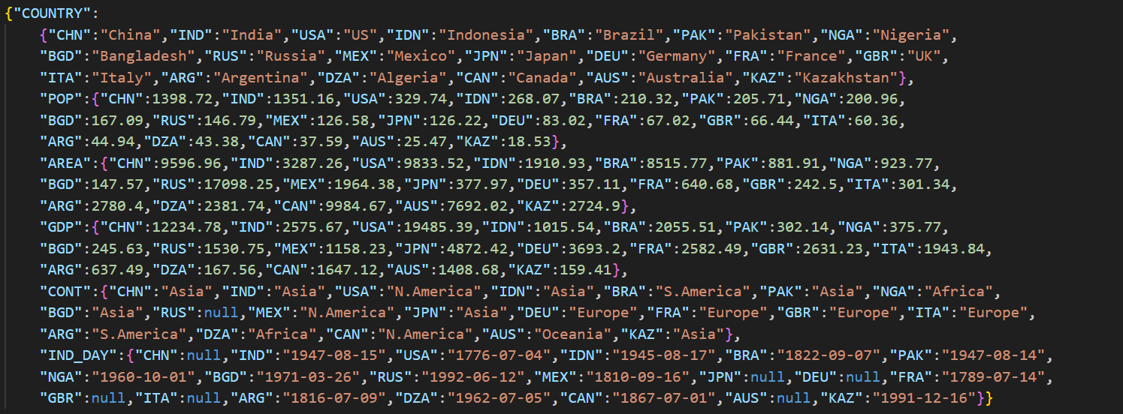

**Task 6:- Read json**

**Python Code:**

import pandas as pd

df7 = pd.read_json('data.json')

print(df7)

**Output:**



**Task 7:- Read HTML**

**Python Code:**

import pandas as pd

data = {

'CHN': {'COUNTRY': 'China', 'POP': 1_398.72, 'AREA': 9_596.96,

'GDP': 12_234.78, 'CONT': 'Asia'},

'IND': {'COUNTRY': 'India', 'POP': 1_351.16, 'AREA': 3_287.26,

'GDP': 2_575.67, 'CONT': 'Asia', 'IND_DAY': '1947-08-15'},

'USA': {'COUNTRY': 'US', 'POP': 329.74, 'AREA': 9_833.52,

'GDP': 19_485.39, 'CONT': 'N.America',

'IND_DAY': '1776-07-04'},

'IDN': {'COUNTRY': 'Indonesia', 'POP': 268.07, 'AREA': 1_910.93,

'GDP': 1_015.54, 'CONT': 'Asia', 'IND_DAY': '1945-08-17'},

'BRA': {'COUNTRY': 'Brazil', 'POP': 210.32, 'AREA': 8_515.77,

'GDP': 2_055.51, 'CONT': 'S.America', 'IND_DAY': '1822-09-07'},

'PAK': {'COUNTRY': 'Pakistan', 'POP': 205.71, 'AREA': 881.91,

'GDP': 302.14, 'CONT': 'Asia', 'IND_DAY': '1947-08-14'},

'NGA': {'COUNTRY': 'Nigeria', 'POP': 200.96, 'AREA': 923.77,

'GDP': 375.77, 'CONT': 'Africa', 'IND_DAY': '1960-10-01'},

'BGD': {'COUNTRY': 'Bangladesh', 'POP': 167.09, 'AREA': 147.57,

'GDP': 245.63, 'CONT': 'Asia', 'IND_DAY': '1971-03-26'},

'RUS': {'COUNTRY': 'Russia', 'POP': 146.79, 'AREA': 17_098.25,

'GDP': 1_530.75, 'IND_DAY': '1992-06-12'},

'MEX': {'COUNTRY': 'Mexico', 'POP': 126.58, 'AREA': 1_964.38,

'GDP': 1_158.23, 'CONT': 'N.America', 'IND_DAY': '1810-09-16'},

'JPN': {'COUNTRY': 'Japan', 'POP': 126.22, 'AREA': 377.97,

'GDP': 4_872.42, 'CONT': 'Asia'},

'DEU': {'COUNTRY': 'Germany', 'POP': 83.02, 'AREA': 357.11,

'GDP': 3_693.20, 'CONT': 'Europe'},

'FRA': {'COUNTRY': 'France', 'POP': 67.02, 'AREA': 640.68,

'GDP': 2_582.49, 'CONT': 'Europe', 'IND_DAY': '1789-07-14'},

'GBR': {'COUNTRY': 'UK', 'POP': 66.44, 'AREA': 242.50,

'GDP': 2_631.23, 'CONT': 'Europe'},

'ITA': {'COUNTRY': 'Italy', 'POP': 60.36, 'AREA': 301.34,

'GDP': 1_943.84, 'CONT': 'Europe'},

'ARG': {'COUNTRY': 'Argentina', 'POP': 44.94, 'AREA': 2_780.40,

'GDP': 637.49, 'CONT': 'S.America', 'IND_DAY': '1816-07-09'},

'DZA': {'COUNTRY': 'Algeria', 'POP': 43.38, 'AREA': 2_381.74,

'GDP': 167.56, 'CONT': 'Africa', 'IND_DAY': '1962-07-05'},

'CAN': {'COUNTRY': 'Canada', 'POP': 37.59, 'AREA': 9_984.67,

'GDP': 1_647.12, 'CONT': 'N.America', 'IND_DAY': '1867-07-01'},

'AUS': {'COUNTRY': 'Australia', 'POP': 25.47, 'AREA': 7_692.02,

'GDP': 1_408.68, 'CONT': 'Oceania'},

'KAZ': {'COUNTRY': 'Kazakhstan', 'POP': 18.53, 'AREA': 2_724.90,

'GDP': 159.41, 'CONT': 'Asia', 'IND_DAY': '1991-12-16'}

}

columns = ('COUNTRY', 'POP', 'AREA', 'GDP', 'CONT', 'IND_DAY')

df6 = pd.DataFrame(data=data, index=columns).T

df6.to_html('data.html')

**Output:**

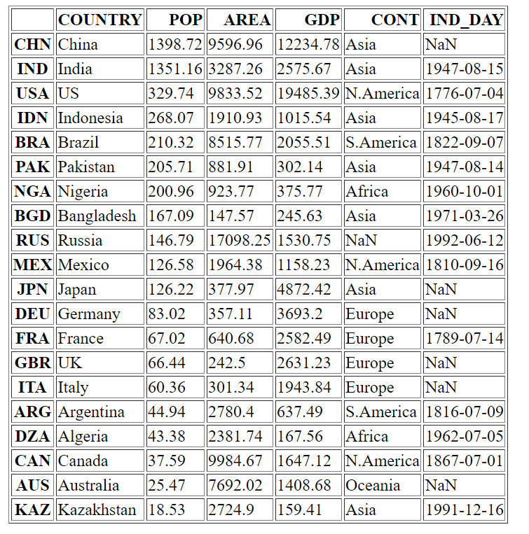

**Task 8:- Implement columns Function**

**Python Code:**

import pandas as pd

df8 = pd.read_html('data.html', index_col=0)

print(df8)

**Output:**

